**CSE 471(SEC-03)**

**Course Name: System Analysis and Design**

**Title of the Project: BLOOD BANK MANAGEMENT SYSTEM**

**Group Number: 03**

**Group Name: Team Thanos**

**Submitted by:**

|  |  |
| --- | --- |
| **Name** | **ID** |
| **MD. AOSAFUL ALAM** | **16101061** |
| **SHAHAN JAMIL BUIYAN** | **16101091** |
| **NAZMUS SAKIB AKASH** | **16101208** |
| **ASHRAFUL JANNAT** | **15101102** |

**USER INTERFACE:**

**Home Page:**

This is the home page or the main page of a blood bank management system. This is the main page of a client side. . This page define all about related to project



**Donor Registration:**

Registration page includes the information of the donor who want to register. Donor can register the account by clicking on new register. He/she can add the account for the further enquiry of the blood donation.

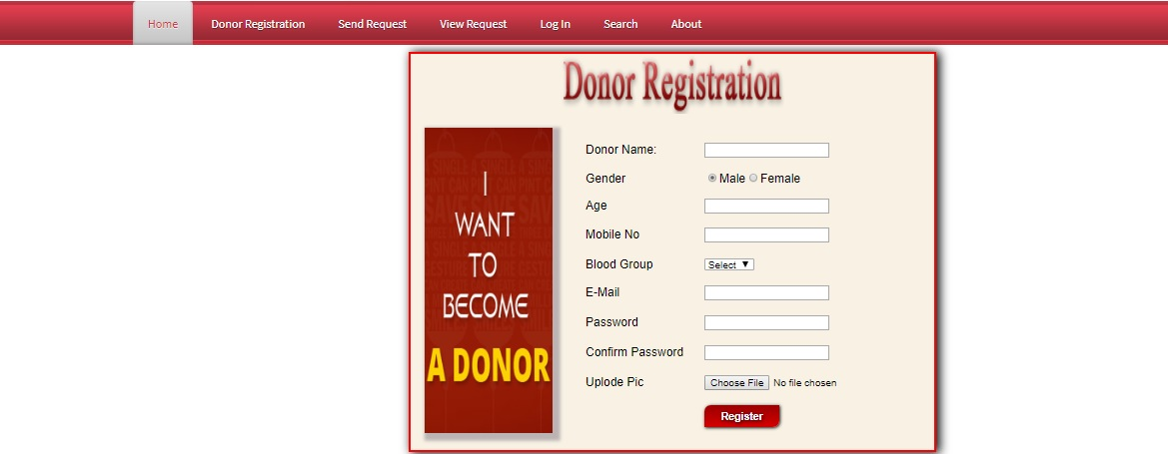

**Send Request:**

Send Request page for the users for those who wants blood. By filling up some query they can request for blood.

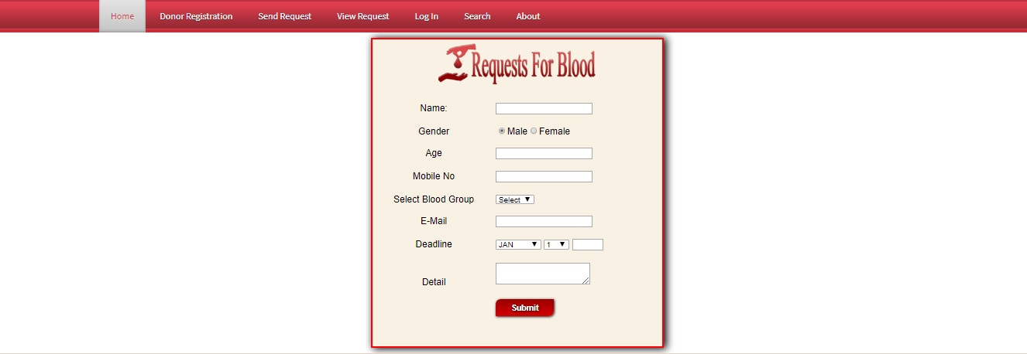

**Donor Login:**

This page is for registered donor who wants to access their profile. By giving email and password they can access the donor panel.

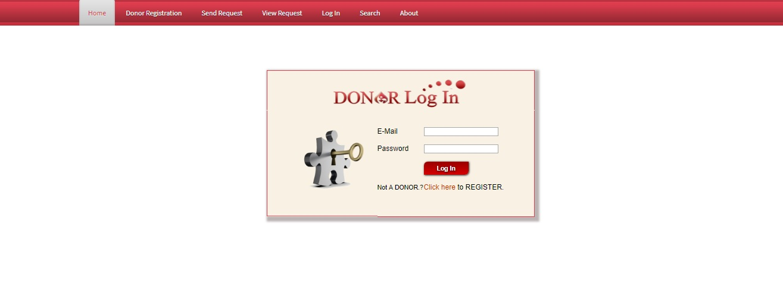

**Donor Panel:**

This page is the welcome page of the donor panel. In this page include all the module related to Donor like:

Change password

Update profile

Blood donated

View requested

Logout

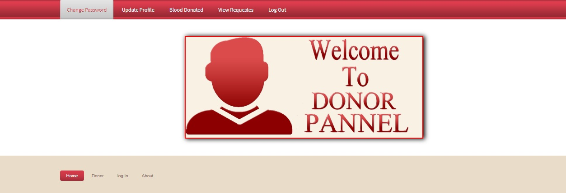

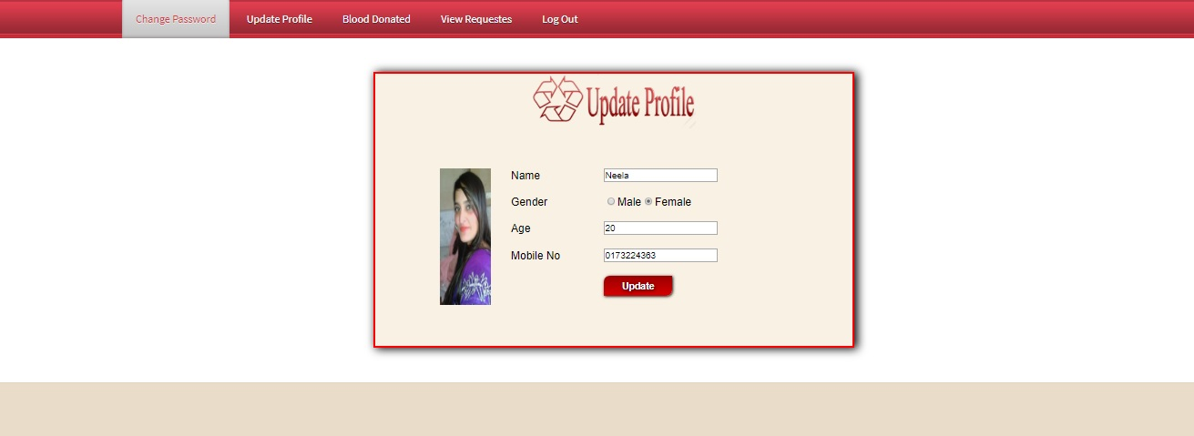

**Search:** Search button is used for search the donations of blood for a different defferent blood groups.

Blood groups name

* A-
* A+
* B-
* B+
* AB+
* AB_
* O+
* O-

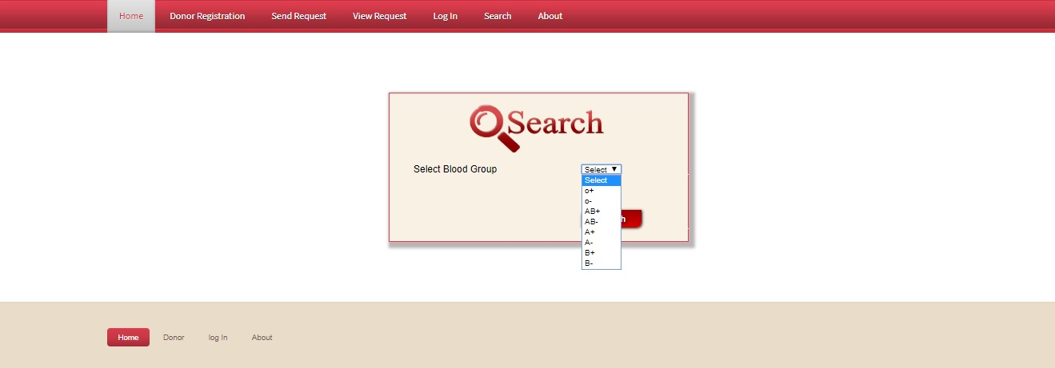

**Contact:**

In contact page any one who wants to need a blood or gaining a information about this system then he/she can contact with us.

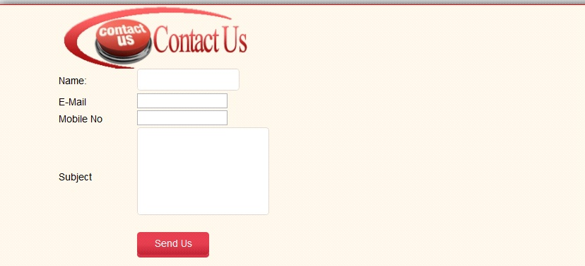

**About:**

This page is basically a letter from our founders.

